The Solent and IOW Pituitary Support Group

# Chairman and Newsletter Editor

Howard Pearce,

18 Wyde Feld,

Bognor Regis,

West Sussex,

PO21 3DH

Tel: 01243 863627

Mobile: 07518 759778

[howardpearce1@yahoo.com](mailto:howardpearce1@yahoo.com)

Joint Area Co-ordinator

Gail Weingartner,

17 Whitfield Road

Haslemere, Surrey

GU27 1DX

Tel: 07525 041947

01428 651526

[g.weingartner@btinternet.com](mailto:g.weingartner@btinternet.com)

Joint Area Co-ordinator

Pam Weingartner,

17 Whitfield Road

Haslemere, Surrey

GU27 1DX

Tel: 01428 651526

Hon Treasurer

Melissa Reeds

80 Kimberley Road

Southsea, Portsmouth

PO4 9NS

Tel: 07894 531879

[mel_reeds@yahoo.com](mailto:mel_reeds@yahoo.com)

Minutes Secretary

Howard Coulson

21 Laburnum Close

North Baddesley

Southampton

SO52 9JT

[green3sky@yahoo.co.uk](mailto:green3sky@yahoo.co.uk)

 

## Newsletter No. 92, September 2025 ______________________________________________

## Hello everyone,

## Welcome to another edition of the Solent and IOW Pituitary Support Group Newsletter, for September 2025.

## Thank you to everyone who has contributed, by sending material for the newsletter and giving their encouragement.

## We aim to produce a newsletter four times a year, and normally it is timed to be issued shortly before each of the main support group meetings at the Cosham Community Centre. However, the next meeting at Cosham is not until Saturday 6 December at 10 am. We had originally planned to have a meeting at Cosham on Saturday 27 September. But instead of this, some of us are going to the big get-together meeting in Southampton on this day, arranged by the Pituitary Foundation. Sorry but it is now sold out, so if you have not yet bought a ticket, it is too late.

## When we meet in December there will be tea, coffee, juice and biscuits. Plus festive food. The meeting will not have a designated speaker this time, but there will be a quiz and a raffle. Please note that NO nuts or nut derivatives are allowed in the Cosham building. There will also be time to chat generally, and to give and receive advice and information about pituitary conditions and related matters.

## We have in the past, often welcomed new patients and their partners, family or friends at meetings, so if you have recently found out you are a pituitary patient or just found out that we as a support group exist, please get in touch and join us for future meetings and you'll be made very welcome.

**Find us on Facebook** - The Solent and IOW page is in the form of a group. Together we'll be updating and posting relevant information on there. Anyone that uses Facebook can search and join the group. It is listed as the following: - The Solent & IOW Pituitary Patient Support Group. This is in addition to the main Pituitary Foundation page and other pituitary Facebook groups.

#### =============== Meeting dates for your diary for 2025 ===============

#### December meeting at Cosham Community Centre, Wootton Street, Cosham, PO6 3AP

#### At the Cosham meetings we will have tea, coffee, juice and biscuits available. You may bring your own snacks if you wish, but please note: NO nuts or nut derivatives are allowed in the building.

* Saturday 27 September. We originally planned a meeting on this date. However, the Pituitary Foundation organised a big get-together meeting in Southampton on this day. So we cancelled the Cosham meeting and are going to Southampton instead. See page 3 for more information.
* **Saturday 6 December 2025 10am** – Our pre-Christmas meeting, with festive food and a quiz

#### =============== Meeting dates for your diary for 2026 – Change of venue ===============

**Note that in 2026 we will no longer be meeting in Cosham. Instead we will be at Porchester Parish Hall, 1 Assheton Ct, Portchester PO16 9PS and at the new time of 10.30am**

* 2026 dates (all Saturdays): 28 March, 27 June, 18 July (IoW), 26 September, 5 December. We do not yet have speakers for all of the 2026 meetings, but we will have the endocrine nurse Sirbrina Ramharack at the September 2026 meeting. We hope to have Dr Lawrence at the Isle of Wight meeting.

Possible speakers for future meetings include Dr James Lawrence and Dr Smith from Salisbury, a radiographer, a pharmacist, and blood bikers, and on mindfulness, laughing yoga, a life coach etc.

There is always a raffle at the main meetings in Cosham (**soon to be Portchester Parish Hall**) and on the Isle of Wight. Prizes gratefully received on the day please.

**Receiving your newsletter -** If you would rather receive your newsletter by email, please email Howard at: [howardpearce1@yahoo.com](mailto:howardpearce1@yahoo.com) or Gail at [g.weingartner@btinternet.com](mailto:g.weingartner@btinternet.com) and let them know. Or let Gail or Howard know if you wish to come off the mailing list altogether.

More than half of the newsletters are now sent out by email. Unfortunately, there are often a few people who have changed their email address, and they do not get their electronic copy. We usually manage to send them a copy by post, but inevitably it is a few days late. If you have changed your email address, please let us know.

**The cost of posting the newsletter** – Printing and postage of the newsletter for those who do not get their copy by email is a major cost item, around £300 a year, and the price of stamps keeps going up. It would be very much appreciated if those receiving the newsletter by post would make some contribution towards the cost of printing and postage, either by stamps or money, or change to email delivery. Gail and Pam Weingartner and Melissa Reeds are always happy to receive a book of stamps from anyone who receives the newsletter by post. They send a special thank you to everyone who has given stamps or money for this.

**It’s your newsletter –** We would love you to write something for the newsletter. If you have something to share – your experience as a patient, something you have done, some wise words, something to make us laugh, or something that we all ought to know – please send it for the next newsletter, which we are aiming to produce in November 2025.

**Donations - [](https://www.google.co.uk/imgres?imgurl=https://handmaidcraft.files.wordpress.com/2014/09/thank-you.jpg&imgrefurl=http://handmaidcraftday.com/2014/09/28/thank-you/&docid=r6J1O3QSDmih4M&tbnid=2t0GrVkXWVDdNM:&w=1106&h=754&ei=RBfzVKDFLK6t7Aabi4H4Dw&ved=0CAIQxiAwAA&iact=c)**Our thanks to our fundraisers for their kind donations and fundraising on our behalf. It is because of the continued support of this kind that we are able to have our quarterly meetings and fund the newsletter. But, we DO NEED some proactive fundraising to keep our bank balance in the black, so please give thought to and let one of us know your ideas.

A special thank you to all who contributed to this newsletter.

**Pituitary Foundation meeting in Southampton in September – Sold out**

The Southampton Get-Together is in September 2025, an opportunity to hear from medical experts and meet others affected by pituitary conditions!

Saturday 27th September, 2025 Time: 10am - 4pm  
Location: Leonardo Royal Hotel Southampton Grand Harbour

W Quay Rd, Southampton SO15 1AG

We’re coming to Southampton for our next Get-Together! These are our in-person events where you get to hear from incredible speakers and meet others affected by pituitary conditions. We can’t wait to bring you all together in the South of England for the first time!

We’ll have brilliant talks from medical professionals, and you’ll also have the opportunity to meet staff and members of The Pituitary Foundation.

About the speakers

**Professor John Wass** – John is a Professor of Endocrinology at Oxford University and was the head of the Department Endocrinology at the Churchill Hospital Oxford. He is also one of the founders of The Pituitary Foundation! John’s talk will include:

* an overview of pituitary conditions within endocrinology
* look at changes in how pituitary conditions can be diagnosed
* changes in the treatment for pituitary conditions
* looking to the future of endocrine care.
* Q&A session

**Dr Sue Jackson** – Sue is a chartered psychologist who researches endocrine disorders, and how the health service can be improved. She’s been involved with The Pituitary Foundation for more than two decades and writes psychological advice for people affected by pituitary conditions. Sue will be running an interactive workshop on relationships and wellbeing. The workshop will include:

• how relationships change when living with a chronic condition

• ways to improve your wellbeing

• opportunities to reflect on certain elements

**Aldons Chua** – Aldons is an Endocrine Clinical Nurse Specialist, based at Barts Health NHS Trust. Aldons also works part time for The Pituitary Foundation, answering calls on the endocrine nurse helpline, and updating our health information. Aldons has a master’s degree in research, and a special interest in adrenal insufficiency. His talk will include:

* Working with your endocrine team
* Preparing for an appointment

The day will also include a chance to hear from others from the community!

The event will be held at Leonardo Royal Hotel Southampton Grand Harbour, West Quay Road, SO15 1AG Southampton. There is car parking available, and it’s just a 15 minute walk from Southampton Central Railway Station. The venue is fully accessible.

If you have any more questions about the day and what to expect, please get in touch with the Head Office by checking the Pituitary Foundation website [www.pituitary.org.uk](http://www.pituitary.org.uk), calling 01173701333 or emailing: [admin@pituitary.org.uk](mailto:admin@pituitary.org.uk).

Sorry but this event is now sold out, and no more tickets are available.

**Our Questions for Dr Lawrence** – great in-depth answers as always (we are sooo lucky). The question I asked is the last one and I had thought it might be fairly simple to answer ! Little did I realise - GAIL

1. *I have a question please! I was with Philip Yeoh (consultant nurse in endocrinology) the other day and he was talking about excess cortisol and the effect on the part of the brain that processes emotions and deals with how you react in those situations. Focussing on increased irritability and less capacitors to deal with emotional situations. I was wondering if Dr Lawrence has any knowledge on this and could expand on the science behind it. I find it very difficult now as I’m often more irritable but don’t want to be and it’s not only frustrating for me but I then feel bad because of how I react in situations. – Charlotte K*

Dear Charlotte, thank you for this question. There has been a recent review of published evidence on this topic which you may wish to look at if you would like very detailed information on it at <https://onlinelibrary.wiley.com/doi/epdf/10.1111/jne.13466> but I will summarise some of the key points here.

As you, but not necessarily everyone else will know, Cushing’s Disease is caused by a benign pituitary tumour that over-produces ACTH which then over-stimulates the adrenal glands to make excess cortisol. Studies show that people, particularly with more severe Cushing’s Disease (higher cortisol levels before treatment) on average experience lower quality of life and higher rates of depression, anxiety, uncertainty, fatigue, and poor memory than people who have not had pituitary disease or people who have had non-functioning pituitary tumours. Perhaps unsurprisingly, those with higher cortisol levels after surgery (which generally means those who were not cured by surgery) reported, on average, even higher rates of fatigue and fear of uncertainty. People with Cushing’s Disease who had a longer delay of diagnosis (between 5 and 30 years) had lower Quality of Life scores compared to patients who were diagnosed earlier. Finally, some (but not all) studies have found that women with Cushing’s Disease had poorer quality of life and more depression compared to men with Cushing’s Disease.

One study found that 3 months after pituitary surgery for Cushing’s Disease, just over half of patients met criteria for a psychiatric illness; 25% met criteria for clinical depression, 7.1% for an anxiety disorder and 10.7% had suicidal thoughts. However, this is a time when the body is still adapting to lower levels of cortisol and some of these symptoms at this stage may be due to the so-called ‘glucocorticoid withdrawal syndrome’ which does typically improve over time.

In terms of more lasting effects, structural brain changes have been investigated in patients with Cushing’s Disease (before and after treatment) using magnetic resonance imaging (MRI) scans. Overall, the presence of active Cushing’s Disease can cause structural brain changes, including decreased overall brain volume.

Achieving remission of Cushing’s Disease can reverse or improve some of these changes but some of these structural brain changes, such as frontal and temporal lobe atrophy (reduction in size of these areas), may still persist after remission.

The frontal and temporal lobes of the brain control advanced cognitive functions such as memory. The volume of a specific part of the frontal part of the brain called the ACC (Anterior Cingulate Cortex) which controls cognitive functions such as decision-making, empathy, and emotion, has been shown to be decreased in patients with Cushing’s Disease in long-term remission compared to healthy controls.

In addition, changes in the hippocampus (a different brain region that is associated with memory) may last even after apparent cure of Cushing’s Disease. These changes were present in patients long after remission from Cushing’s Disease and does further suggest that prolonged exposure to excess cortisol could have long term effects on parts of the brain that are important for cognitive and emotional function.

As always, it is important to say that this does not affect everyone and does appear to depend on the severity of the Cushing’s Disease, the length of time this was present before treatment, the success of treatment and possibly the gender of the individual with it. However, perhaps it could be helpful for you to know that some of the issues you describe certainly do have a scientific basis and having issues such as you describe after recovering from Cushing’s Disease is certainly something that many others in your situation do experience. I hope this is helpful at least for you to understand things even if it does not immediately lead to a solution.

1. *I would like to ask Dr Lawrence; If you don’t have a pituitary gland as I don’t, can you still produce adrenaline and any hormones? – Helen T*

Dear Helen, this is a good question and one that many people probably will be curious about.

The short answer is ‘yes’, many hormones are still produced when the pituitary gland has been removed or isn’t working properly even though the pituitary is sometimes called the ‘conductor of the endocrine orchestra’. The pituitary makes 8 hormones, 6 from its front or ‘anterior’ part and 2 from the back or ‘posterior’ part. The anterior pituitary hormones are prolactin (responsible for milk production and reduced fertility when breastfeeding), LH and FSH which control the ovary or testis to produce sperm/eggs and oestrogen/testosterone, TSH which regulates the release of thyroid hormones from the thyroid and GH which regulates growth in children and has some other actions in adults. Finally, the anterior pituitary produces ACTH which regulates cortisol (and other hormones) from the adrenal gland.

The posterior pituitary releases Vasopressin which regulates water excretion from the kidney and oxytocin which has roles in childbirth and emotions/social behaviours/bonding. Of course, things are quite a bit more complicated than this but these are the essentials.

Most other hormones are regulated or released via mechanisms that do not directly rely on the pituitary although there may be some overlap of actions between pituitary and non-pituitary hormones. Adrenaline is a good example. This is released from the inner part of the adrenal gland (adrenal medulla) in response to nerve signals from the sympathetic nervous system (sometimes described as the ‘fight or flight’ system) and its release does not depend directly on the pituitary. Of course, as previously mentioned, things are more complicated so that, for example, one of the roles of cortisol is to make the body more responsive to adrenaline. In addition, the hypothalamus (the part of the brain just above the pituitary which controls many pituitary actions) is involved in this stress response and will often activate pituitary stress hormones (e.g. ACTH) at the same time.

There are some people who have had both adrenal glands removed (e.g. to treat Cushing’s Disease) who may ask ‘what about my adrenaline?’ The answer to this seems to be that, in humans, adrenaline itself doesn’t appear to be terribly important. When the fight or flight system is activated, many things happen which are driven by the nerves of the sympathetic nervous system directly. In addition, the chemical transmitter that these nerves use, ‘noradrenaline’ is very similar to adrenaline and under intense activation, so much finds its way into the blood stream that there doesn’t appear to be any particular issue if adrenaline itself cannot be released.

Broadly speaking, there are 50 or more hormones (possibly many more) in the human body and even if the pituitary is not working, and even if there may be some interplay between pituitary hormones and many of the non-pituitary hormones, most of these will carry on working as normal. This includes, for example, insulin and glucagon regulating blood glucose, parathyroid hormone regulating blood calcium, renin regulating salt balance, gut hormones and leptin regulating appetite and weight and melatonin which has a role in sleep.

*2(b) I’ve been taking the same brand of Hydrocortisone for 14 years, and my pharmacy is struggling to get hold of it now. It’s Accord. I’m scared to take another brand and have become dependent on Accord. Should I be concerned about trying something else?  I tried another brand of Hydrocortisone once for a short period of time and I felt it didn’t agree with me. I had a Craniopharyngioma and take all the usual replacements, Levothyroxine, Desmopressin acetate, and growth hormone injection at night. Thank you – Helen T*

Dear Helen, this is another good question and you are right to think that the formulation of some medicines (how the drug is mixed with other substances and sometimes fitted into a coat or capsule) can affect the way that it is absorbed or works. For some drugs, this is very important indeed and people must not change their formulation. There have been a few situations in the past where a formulation of hydrocortisone has been found to have a different effect and has been withdrawn as a result. This has generally been in relation to doses for young children where a suspension that tastes nice, or granules that don’t have any taste that can be sprinkled on a very young child’s food, is formulated for this specific market. One such suspension called Cortef oral suspension (Pharmacia & Upjohn) was made by changing the suspending agent (something called ‘tragacanth’) to xanthan gum and it turned out that this prevented the hydrocortisone from being properly absorbed leading to the drug being withdrawn from the market in 1998. Hydrocortisone formulations are now required to undergo ‘bioequivalence’ testing which means testing to show that absorption is the same as a ‘standard’ hydrocortisone formulation so there should not be much difference between tablets now. It is hard to know why it didn’t work for you last time. I guess you may have reacted badly to whatever ‘excipients’ (other substances added as fillers) were in the tablet or perhaps it was a one off. It might perhaps be worth trying again, maybe with a different formulation to the one that didn’t agree with you, now that the appropriate testing is routinely done.

1. *I underwent transsphenoidal surgery early in 1993 and then radiotherapy a little later in the year due to residual adenoma in the sphenoid sinus. Back then, it wasn’t readily accepted that over time radiotherapy can affect the memory; whereas now I believe it is certainly thought to be the case. Increasingly, I struggle with my memory especially long term but now also with more recent events and conversations. I have just had my 66th birthday so am deemed an OAP because I now receive my state pension and I can therefore appreciate that some memory loss is probably due to me ‘moving up the maturity ladder’. Also, perhaps my brain needs a little sieving to rid itself of the rubbish that has built up over the years, lol 🤣. During interaction with pituitary patients, many others also report that they are concerned about their memories.*

*Anyway, my question is, has any research been carried out as to the extent radiotherapy can affect the memory or, if no research, what is the consensus opinion if any ?*

*Thank you – Gail W*

Dear Gail, thank you for your question and as expected, it is a difficult one. There has been a recent ‘review’ of all previous research which you may wish to look at https://pmc.ncbi.nlm.nih.gov/articles/PMC12074915/.

I think it is probably best summarised as:

1. There have been many studies looking at memory and ‘cognitive’ outcomes for pituitary patients although with many differences in the type of study, type of participant, duration of follow up etc. Perhaps unsurprisingly, there have been many different and sometimes conflicting results
2. It is a difficult field to do research in as patients may have very different experiences
   1. Functioning tumours (e.g. acromegaly, Cushing’s, prolactinoma) vs. non-functioning tumours which don’t release active hormones
   2. Different size of tumours (e.g. microadenomas < 10mm in diameter vs. larger ‘macroadenomas’ > 10mm vs. massive tumours which may grow to compress the brain
   3. Different complications (some tumours may bleed causing ‘apoplexy’, some patients may have complications of surgery which can rarely include meningitis)
   4. Different operations or none at all (e.g. via the nose, via the front or side of the head requiring the brain to be retracted out of the way)
   5. Different need for radiotherapy, different types of radiotherapy and different sizes of radiotherapy target
   6. Different treatments may be used (e.g. cabergoline for a prolactinoma)
   7. Different hormone deficiencies after treatment (ranging from no deficiency to full deficiency of all pituitary hormones)
3. The studies have shown rather variable results overall with some showing little evidence of cognitive/memory issues although most do show at least some effects of having had a pituitary tumour
4. Slightly surprisingly, having radiotherapy nor the size of the tumour appear to have a significant effect in these studies. I do wonder whether they would have had long enough follow up periods to detect all complications though as radiotherapy effects for example may not show up for very many years after the treatment is given
5. What did appear to be the biggest factor was where there was significant hormonal disruption.

The authors of this ‘state of the art’ review conclude that *‘This comprehensive review included 70 studies spanning a 50-year period, involving nearly 4,000 patients. Although derived from studies using a wide range of cognitive assessment tools, our data indicate significant cognitive impairment in patients with PA, particularly affecting executive function and memory. Surgical treatment has been associated with improvements in cognitive function, while RT has no detrimental effect on cognitive performance. Tumour size was not associated with the severity of cognitive dysfunction; instead, our findings suggest that hormonal imbalances are the primary factor underlying impaired cognition in patients with pituitary adenomas’.*

I think looking at all of this evidence, it will probably be no surprise to you to learn that the effects of having a pituitary tumour, especially one that is hormonally active, undergoing the necessary treatment (surgery and radiotherapy), and ongoing treatment for pituitary insufficiency may end up having some effects on memory and cognition in addition to those that inevitably come with age. It is important to remember what an average means though. This does not mean that all people that live with pituitary conditions are affected and many may be just as happy/cognitively sharp or even happier/more cognitively sharp than people who have not had pituitary conditions. It does mean that, if you look at large groups, there is a difference in the average. I think we certainly have a better understanding of this than perhaps we had in the past and I think this has led to more definitive treatment of e.g. Acromegaly and Cushing’s Disease and less use of radiotherapy which used to be given much more routinely in the past than it is now. In addition, routine supplementation of growth hormone to people with severe deficiency may well be having a beneficial effect on people and this may not fully have been captured in these studies, some of which pre-dated widespread growth hormone supplementation and I think it is probably true to say that many other aspects of hormone replacement have also improved during the 50 years covered by this review so perhaps the situation may be a little better now than it was in the past.

**Steve Harris**

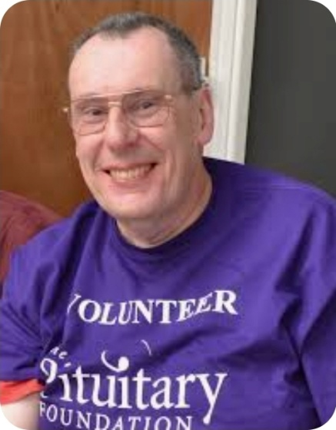Gail says - It is with great sadness that I am writing this short piece due to the unexpected passing of Steve Harris on Friday 22nd August. Steve was a very dear friend of some 30 years and who initiated and headed the Birmingham pituitary support group for many years. Lots of you may well have spoken to Steve on the Helpline and he was often a representative for the Pituitary Foundation at many events together with proof reading for the Pituitary Life magazine and also information leaflets. You could always turn to Steve for IT help and advice but above all of course, for his considerable pituitary experience and his amazing capacity for understanding & empathy. He also had a great sense of humour.

My nickname for Steve was HRH, His Royal Hipponess, because of his love of the fearsome hippopotamus and he will be so very sorely missed. Thanks HRH !

**Stop press – moving from Cosham to Portchester**

As you all know, we have been using the Cosham venue for our meetings for many years but recently the service they provide has not been as we would expect. As a result, we have been looking into a change of venue and have visited two possible venues in Portchester, both of which are good, with kitchen access, parking etc.

Following our discussion at the committee meeting recently, and taking into account your valuable feedback, we have decided to change our venue from Cosham to Portchester Parish Hall (the smaller hall). The address is 1 Assheton  Court, Portchester, Fareham PO16 9PS. We are impressed with the facilities, the disabled spaces/access/kitchen and adjacent free parking. The change will take place for our meeting on 28 March next year and the start time will change from 10 am to **10.30 am.** We think this time will be better for everyone. We have been developing plans to make it a great meeting! Full details to follow later.

It you have any questions or concerns please email: [jenny.gatland@googlemail.com](mailto:jenny.gatland@googlemail.com)

**Beth’s skydive for The Pituitary Foundation, from Bob and Pat Hobbs.**

Beth Murthwaite is raising money for The Pituitary Foundation

Absolutely awesome massive well done to our Granddaughter, Bethanie Murthwaite for the amazing amount made for the Pituitary Foundation Charity who have given us so much support and advice on Pat’s pituitary condition PanHypopituitarism (Sheehans Syndrome) since 2009 .

Massive thanks to all who have sponsored Bethanie, at present she has raised over £1000 on her just giving page on Facebook. It’s so lovely of you all. A Massive thanks to everyone that came to support her at Sandown airport on her first ever Sky Dive from 12,000 ft here on the Isle of Wight on the 19th August. We hope you all like the few pictures provided.

There were quite a few pictures of the event. Here are three of them – before, during and after the action. Well done Beth.

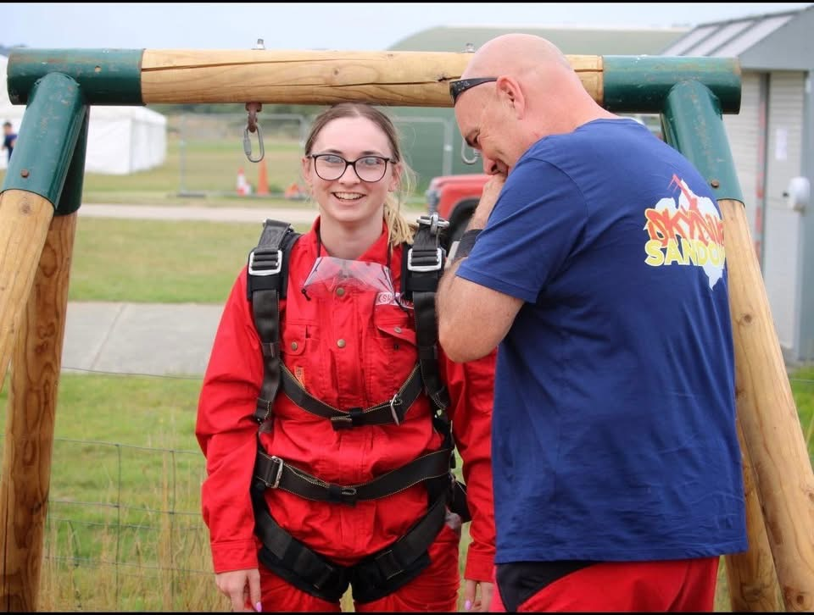

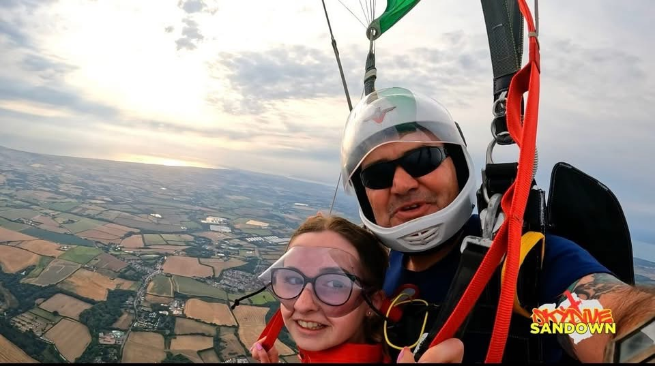

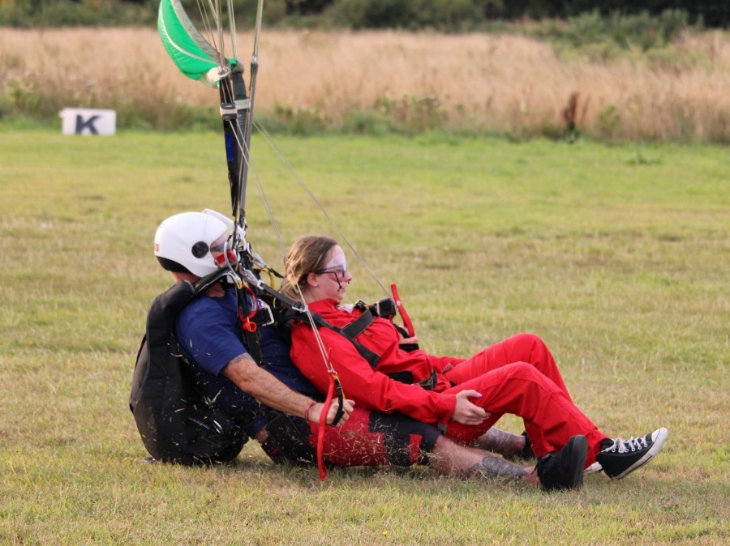

**Infections and Inflammations of the Pituitary Gland (from LAPPS)**

Dr Bano explained Infections of the hypothalamic-pituitary region are rare and described in case reports or small case series. They are treatable. These infections include bacterial infections (pituitary abscess), tuberculosis, fungal, viral, and parasitic infections. All can cause hypopituitarism. An infection in the hypothalamic-pituitary region may present as a sella/suprasellar mass and may be misinterpreted as a pituitary tumour. These infections may cause hypopituitarism and be misdiagnosed.

Infections of the hypothalamic-pituitary region may be primary (without an identifiable source) or secondary in origin. Primary pituitary infection is more common and occurs in previously healthy normal pituitary glands. Secondary pituitary infections occur in patients with a pre-existing lesion in the pituitary region (pituitary adenoma, Rathke’s cleft cyst, craniopharyngioma, or prior pituitary surgery). There are several sources of infections in the hypothalamic-pituitary region.

**Sources of Infections Spreading to the Hypothalamic-Pituitary Region**

This can be caused by immunocompromised host, meningeal infection, sphenoidal sinus and cavernous sinus. Also, surgical intervention in sellar and suprasellar region, and tooth extraction.

**Predisposing factor for pituitary infections**

There are many factors that can cause the infections, including Diabetes Mellitus, tuberculosis, solid organ transplant (renal, liver etc), HIV infection, non-Hodgkin lymphoma, chemotherapy, Cushing’s syndrome, previous pituitary surgery and immunosuppressive therapy.

**Clinical features of pituitary infections**

Neurological symptoms include headache, visual disturbances and cranial neuropathy.

Endocrine Dysfunction include Hyponatremia, Hypopituitarism, Hypogonadotropic

hypogonadism, isolated ACTH deficiency Hyperprolactinemia and AVP deficiency (previously called DI).

**Pituitary Abscess (PA)**

Pituitary abscesses account for less than 1% of all pituitary lesions. The first case of a pituitary abscess was described in 1848 and since then it has been mostly described in case reports or small series. According to the clinical presentation and duration of the disease, pituitary abscesses can be acute, subacute (the disease course less than 1 month), or chronic (disease course longer than 1 month). Infective manifestations (fever, leukocytosis, meningism) have been reported in patients with acute and subacute pituitary abscesses, while chronic pituitary abscesses have a more indolent course.

**Summary**

A pituitary abscess is an infectious process characterized by the accumulation of purulent material in the Sella turcica. It is **rare** and can be a life-threatening condition unless promptly diagnosed and treated. The clinical presentation of PA is nonspecific, such as headaches, pituitary hypofunction, and visual disturbances. MRI in PA can present as a suprasellar mass (65%) or as an intrasellar mass (35%). The diagnosis of PA in most cases can only be confirmed after surgical exploration. The treatment for PA in patients with mass effect is Transsphenoidal excision (TSS) with decompression of sella and antibiotic therapy. Antibiotic therapy should be started promptly even in the patients who are waiting for microbiology and histological confirmation for about 4–6 weeks Hormone replacement is commenced depending on the hormone deficits

**Conclusion**

• All Pituitary masses are not tumours

• Hypopituitarism is not the diagnosis but a manifestation of an underlying disease

• Look for the cause of Hypophysitis

• Polyuria and polydipsia due to AVP deficiency is again a symptom, it needs investigate extensively for the cause.

**News of upcoming on line events by the Pituitary Foundation**

We’ve got lots of exciting online events coming up during October, which is Pituitary Awareness Month:

* Caring for a Child with a Pituitary Conditions, with Dr Indi Banerjee and Helen Stokes - 6pm 2/10/25
* Benefits and Chronic Conditions, with Lawrence Barratt and Rachel Ingleby - 6pm 6/10/25
* Pregnancy and Pituitary Conditions, with Dr Rebecca Scott - 6pm 13/10/25
* Managing Life Changes, with Dr Sue Jackson - 6pm 21/10/25
* General Q&A, with Professor John Wass - 6pm 28/10/25

If you’d like to sign-up to attend any of these events for free, please click the link below.

<https://www.pituitary.org.uk/join-our-community/all-events/?event-category=online-events&current_page=1>

**Isle of Wight meeting**

For several years our meeting on the island has been in Lake. But after the mix-up about the date last year, we decided to try out a new venue, the Gracellie Hotel in Shanklin. Everything was organised with the manager at the hotel.

However, when we arrived at the hotel, about half an hour before the meeting was due to start, the hotel staff told us they had no idea that we were coming. Worse, they said they did not have a room available for us to use. Apparently the former manager had left, and had not passed on his approval of our use of the hotel to the new people.

For a while several of us were on line investigating possible alternative venues and making telephone calls, and were unable to find anywhere suitable at such short notice. Fortunately, one of the hotel staff team took pity on us and said we could use the hotel bar area. It was not particularly well lit, but once we had moved lots of chairs into position, it was good enough for our purposes.

Then, as always, Dr Lawrence from St Mary’s Hospital in Newport was brilliant. He answered our questions with plenty of detail and I am sure that everyone learned a lot, and we realise just how complex our endocrine system is.

We will be searching for a more suitable venue on the island for 2026 – **any ideas, please get in touch with Gail** [**g.weingartner@btinternet.com**](mailto:g.weingartner@btinternet.com) **or 07525 041947**

**An apology**

It has been flagged by the Foundation's National Support Office that in the June edition of our newsletter, the closing item 'Facts that will blow your mind', which was included as a humorous finish as we usually do, might have caused offence to some people.  This was only in the copy which was sent out by email and was deleted from the posted edition.

We would therefore, like to apologise if anyone was offended and also say that this content did not represent the views of the Foundation.

**A little newsletter humour to sign off with, all thanks to Paul Oastler.**

Hi all, the quiet one here (although getting slightly louder 😁).

I thought I'd start this off with a none medical bit about my experience at the Victorious Festival in Southsea. For the third year running I have attended all 3 days. Why? I hear you say; well my answer to that is, it seemed like a good idea at the time. I booked before last Christmas not knowing who was performing and having watched them, I've still got no idea who most of them were 😏.

The walk home was challenging to say the least, but I still enjoyed the whole experience. Actually, there is a medical story to this. My carer, nurse, doctor and wife (all four are the same person), advised me to double the dose every day, although unfortunately, I misinterpreted what she meant and instead of 5 pints I had 10. An easy enough mistake to make !!

Ok back to the medical bits; you will all be so pleased to know I have a new sleep apnoea machine, which looks like a 1970's teas-made machine (remember those). It was a very emotional time for me as Susan and I had been together for 11 years and we had many a holiday together, Spain, New York to name a couple. I really must take the wife next time lol 🤣.

When I first got diagnosed with a pituitary tumour in 2008, I had no idea what it was, so naturally I was straight on the internet. Although the internet is a fantastic thing, my advice to anyone just starting out on your pituitary journey is to not read too much into what people say on there. It is only my personal opinion but it just seemed at the time that a lot of people who write their experiences on there have bad ones and tend not to tell us about the good results, which most of us have thankfully. Listen to your body is my advice, says me having just spent 3 days walking around Southsea common ! I say all this just as I have joined a sleep apnoea 'Fakebook' group (Facebook) and the same sort of thing happened.

Blimey, I've gone all serious so maybe it’s time for a joke. I am not sure if you knew they have brought out a thought-controlled air freshener. You know it makes sense.

And, I am now the proud owner of an allotment, which seemed like a good idea 4 years ago when I applied for it.

So, if you see bucket loads of Tomatoes, Spuds and Blackberries at our group's Christmas do, then 'dig' into your knowledge of where they came from. Jill says you can buy all this lot for 80p over Tesco's, but my answer to that is, yes but they're not covered in dirt with free worms, snails and slugs, are they ?

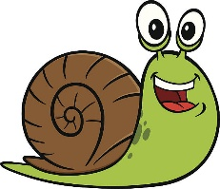Talking of snails you'd think if you removed their shells it would make them faster. But it just makes them more sluggish.

Please one more joke I hear you say, ok if you insist.

I'm not sure if any of you have tried blindfold archery? ....... If you haven't then you don't know what you're missing.

If you’re feeling lonely or just fancy a chat, then give Gail a call on either of the numbers shown on the first page. Stay safe and thanks soooo very much for your personal contributions folks.

Gail, Pam, Howard P, Melissa, Jodie, Jenny, Jackie, Eireen & Howard C